Project Design Phase-II
Technology Stack (Architecture & Stack)

Date | 30 September 2026
Team ID | SWTID-2026-1800
Project Name | AI FITTRACK API
Maximum Marks | 4 Marks

Technical Architecture:
The Deliverable shall include the architectural diagram as below and the information as per the table1 & table 2
Technical Architecture - AI FITTRACK API
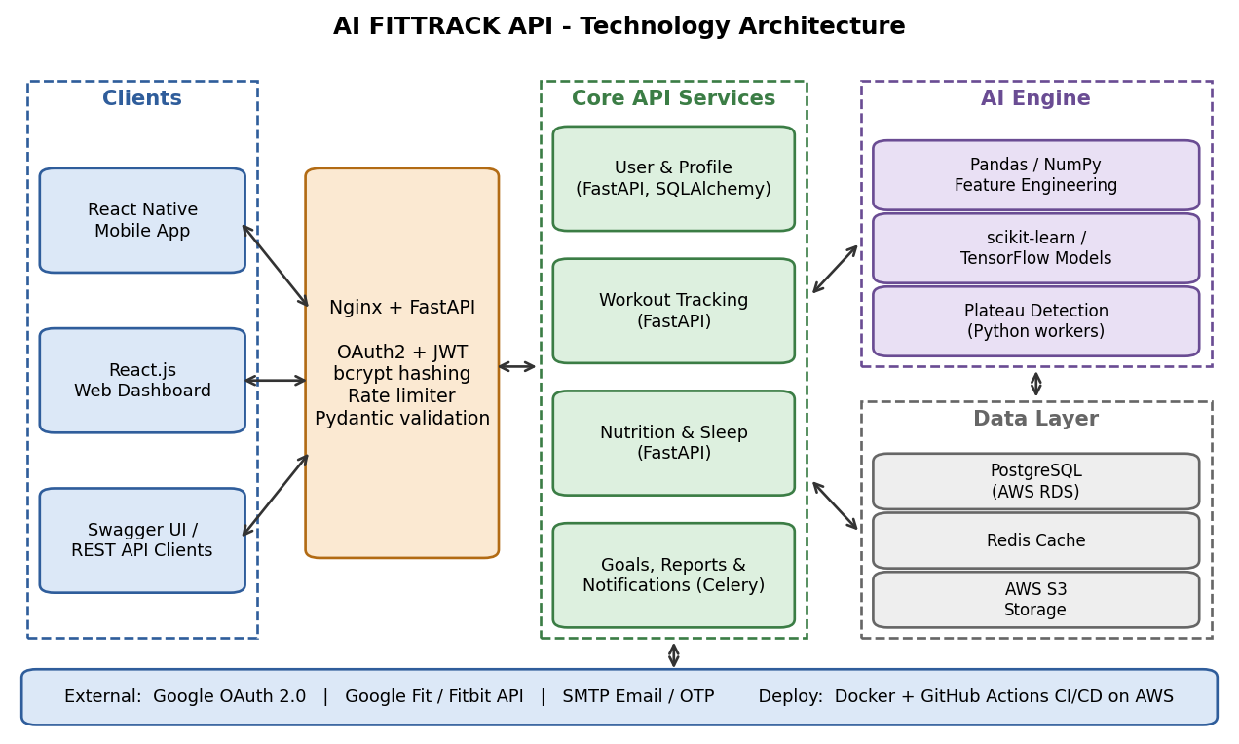

Table-1 : Components & Technologies:
S.No | Component | Description | Technology
 | User Interface | Web dashboard and mobile app through which users log activity and view plans and reports; Swagger UI for developers | HTML, CSS, JavaScript, React.js, React Native
 | Application Logic-1 | Core REST API: authentication, profile, workout, nutrition and sleep management | Python, FastAPI
 | Application Logic-2 | AI recommendation engine: personalised workout plans, calorie / macro targets, plateau detection | Python, Pandas, NumPy, scikit-learn
 | Application Logic-3 | Notification and reporting service: reminders and weekly progress reports | Celery, Redis, SMTP email
 | Database | Relational data for users, workouts, meals, sleep and goals | PostgreSQL
 | Cloud Database | Managed database service on cloud with automated backups | AWS RDS for PostgreSQL
 | File Storage | Profile images, exported reports and trained model files | AWS S3 / local filesystem (development)
 | External API-1 | Google sign-in for quick registration and login | Google OAuth 2.0 API
 | External API-2 | Sync of steps, heart rate and activity from wearables | Google Fit API / Fitbit Web API
 | Machine Learning Model | Recommends workouts and calorie targets and detects plateaus from user history | Random Forest / K-Means (scikit-learn), TensorFlow
 | Infrastructure (Server / Cloud) | Application deployment on local system / cloud  Local Server Configuration: Python 3.11, 4 GB RAM, 2 vCPU  Cloud Server Configuration: 2 vCPU, 4 GB RAM instances behind a load balancer | Docker, AWS EC2 / ECS, GitHub Actions (CI/CD)

Table-2: Application Characteristics:
S.No | Characteristics | Description | Technology
 | Open-Source Frameworks | FastAPI, SQLAlchemy, Pydantic, Pandas, scikit-learn, React.js | FastAPI, scikit-learn, PostgreSQL
 | Security Implementations | JWT-based authentication, password hashing, HTTPS / TLS, role-based access control, rate limiting and input validation as per OWASP Top 10 | JWT, bcrypt, TLS, OWASP
 | Scalable Architecture | 3-tier architecture with stateless API services and a separate AI service; horizontal scaling with containers and database read replicas | Docker, load balancer, PostgreSQL replicas
 | Availability | Multiple containers behind a load balancer, health checks, automatic restart and automated database backups | Nginx / AWS ALB, AWS RDS backups
 | Performance | Design target of about 500 requests per second; Redis cache for frequent reads, asynchronous endpoints, database indexing and pagination | FastAPI (async), Redis, Uvicorn / Gunicorn

References:
https://c4model.com/
https://developer.ibm.com/patterns/online-order-processing-system-during-pandemic/
https://www.ibm.com/cloud/architecture
https://aws.amazon.com/architecture
https://medium.com/the-internal-startup/how-to-draw-useful-technical-architecture-diagrams-2d20c9fda90d

